**Compiler Design – UE20CS353**

**Assignment-1**

**Name:** Vishwa Mehul Mehta

**SRN:** PES2UG20CS389

**Sec:** F

**Date:** 05-03-2023

**Valid Test Cases:**

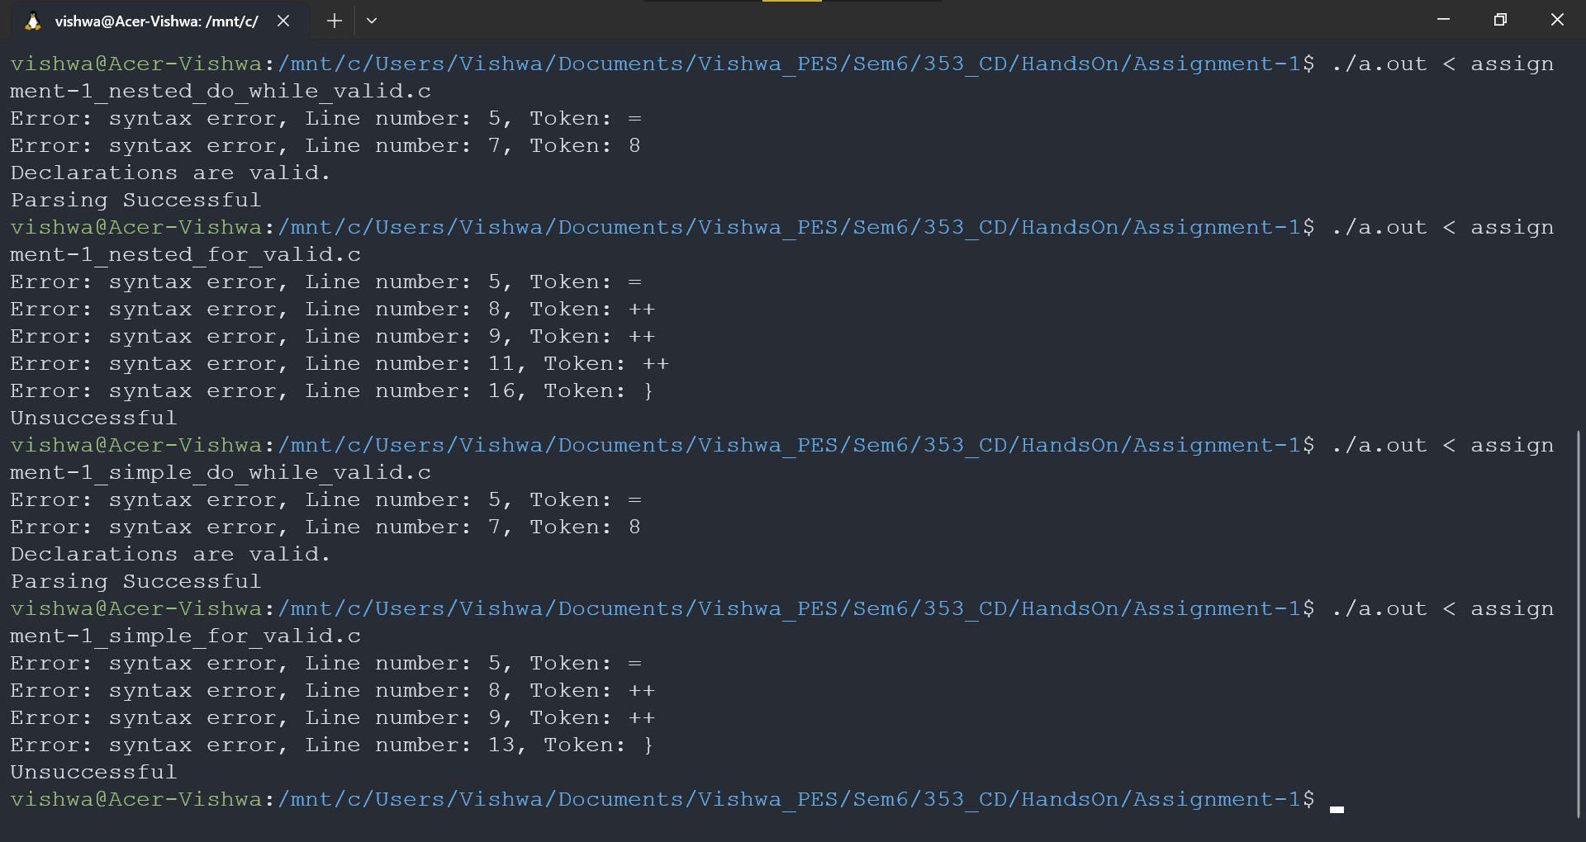

**Invalid Test Cases:**

